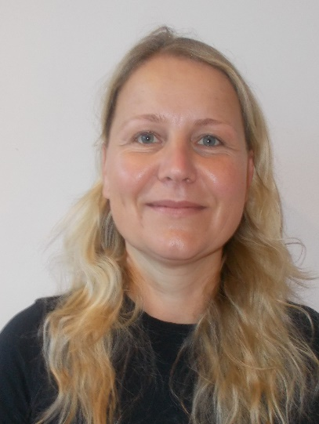
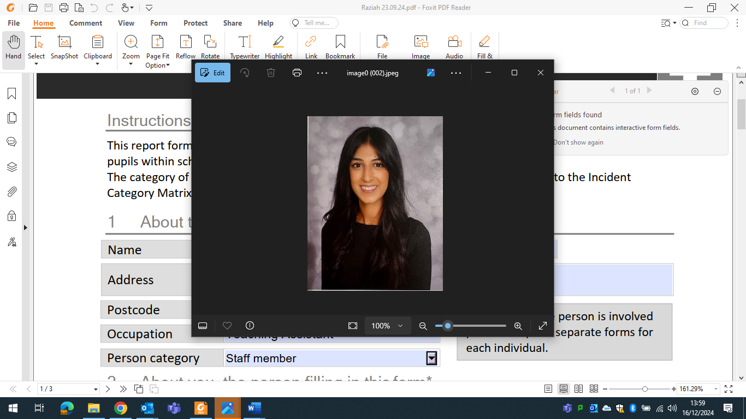
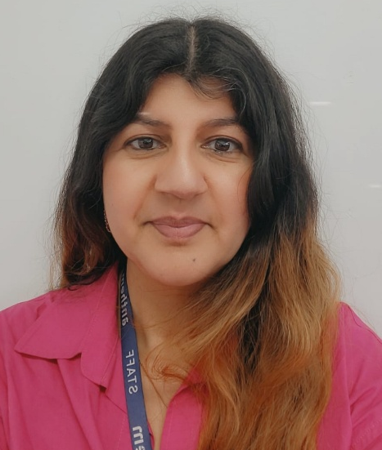

`

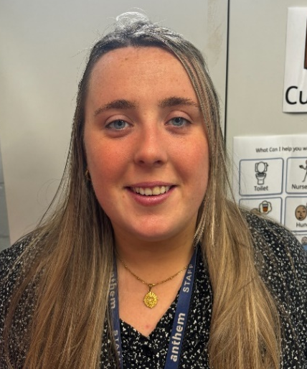
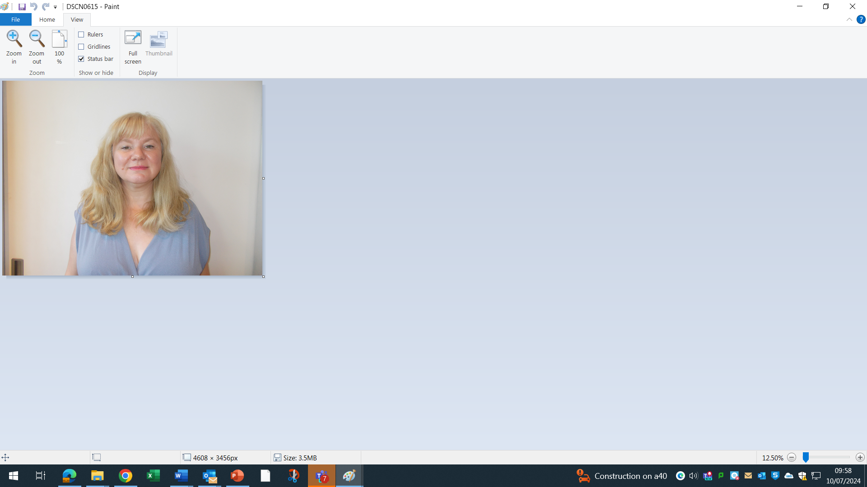
Deputy Designated Safeguarding Lead
Marcela Skoupilova
SENCO
Designated Safeguarding Lead
Azra Hussain
Headteacher
Deputy Designated Safeguarding Lead
Rohan Dhillon-Freeman
Deputy Headteacher

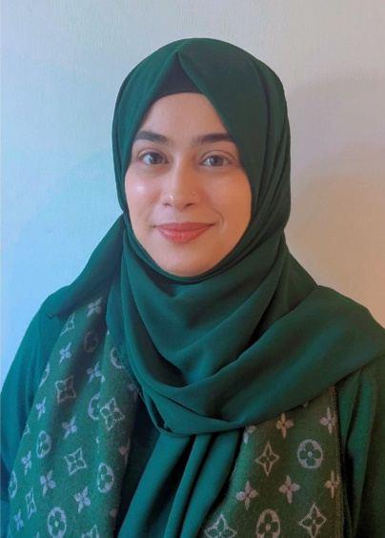

Deputy Designated Safeguarding Lead
Viktoria Driscoll-Mooney
Welfare Officer
Deputy Designated Safeguarding Lead
Sonia Rea
Assistant SENCO
Deputy Safeguarding Lead
Maryam Ayyaz
Attendance and Admissions

