Year 4
Term |  |  | Autumn |  | 1 |  |  |  |  | Autumn |  | 2
Theme | Finding Freedom |  |  |  |  |  |  | Invention and Innovation
Writing | Fryndleswylde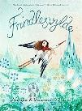  Natalie and Lauren O’hara |  |  |  | 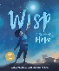Wisp – the story of hope  Zana Frallion and Grahame Baker-Smith |  |  | 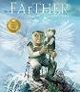  Farther  Graham Baker Smith |  |  |  | 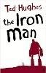  Iron Man  Ted Hughes
Type | Classic poetry |  |  |  | Cornish legend picture book |  |  | Contemporary picture book |  |  |  | British classic fiction
Outcome | Explanation |  |  |  | Own version legend |  |  | Sequel |  |  |  | Narrative
Reading | 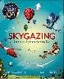  Skygazing or Dear Earth |  |  |  | 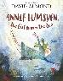  Annie Lumsden, Girl from the sea  David Almond |  |  | 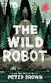  Wild Robot  Peter Brown |  |  |  |  | School’s own Christmas/winter choice
Type | Non fiction about the sky |  |  |  | Contemporary fiction mythical |  |  | Contemporary fiction
Focus | Retrieve and record. Knowledge. Fluency |  |  |  | Features of a mythical story. Fluency. |  |  | Inference, plot and character and themes. Reading stamina
Term |  |  | Spring |  | 1 |  |  |  |  | Spring |  | 2
Theme | Darkness and light |  |  |  |  |  |  | Taking Courage
Writing | 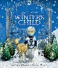  Winter’s Child  Angela McAlister |  |  |  | 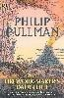  The Firework Makers Daughter  Phillip Pulman |  |  | 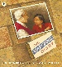  Matchbox Diary  Paul Fleischman |  |  |  | 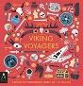  Viking Voyagers  Jack Tite
Type | Contemporary picture book |  |  |  | Modern Classic fiction |  |  | Migration picture book |  |  |  | Non-fiction historical
Outcome | Sequel |  |  |  | Book review |  |  | Biography |  |  |  | A day in the life
Reading | The Firework Makers Daughter  Phillip Pulman |  |  |  |  | 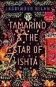  Tamarind and the star of Ishta,Jasbinder Bilan |  |  |  | Viking Voyagers  Jack Tite
Type | Modern Classic fiction |  |  |  |  | Contemporary fiction, Indian/Himalayan adoption |  |  |  | Non-fiction historical
Focus | Plot and character and themes |  |  |  |  | Character and inference and themes |  |  |  | Retrieve and record. Knowledge.
Term |  |  | Summer |  | 1 |  |  |  |  | Summer |  | 1
Theme | Exploration and discovery |  |  |  |  |  |  | Humour and wonder
Writing | 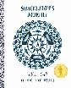  Shackleton’s Journey  William Grill |  |  | 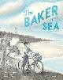  The Baker by the Sea  Paula White |  |  |  | 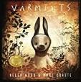  Varmints  Helen Ward |  |  | 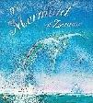  The mermaid of Zennor  Charles Causley
Type | Re-telling of a true story |  |  | Contemporary fiction, values and virtues |  |  |  | Contemporary picture book – environment |  |  | Contemporary fantasy fiction
Outcome | Report |  |  | Tourism writing |  |  |  | School’s choice |  |  | Narrative sequel
Reading | 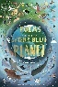  Poems from a green and blue planet  Sabrina Mahfouz |  |  | 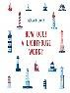  How does a lighthouse work?  Roman Belyaev |  |  |  | 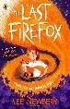  The Last Firefox  Lee Newbury |  |  |  |  | Fluency performance
Type | Poetry |  |  | Non-fiction |  |  |  | Contemporary fiction |  |  |  |  | School’s choice
Focus | Fluency and language |  |  | Retrieve and record. Knowledge. |  |  |  | Character and inference and themes |  |  |  |  | Fluency

